# Objects and its internal representation in JavaScript

JavaScript is designed on a simple object-based paradigm. An object is a collection of properties, and a property is an association between a name (or key) and a value. A property’s value can be a function, in which case the property is known as a method.

A JavaScript object has properties associated with it. A property of an object can be explained as a variable that is attached to the object. Object properties are basically the same as ordinary JavaScript variables, except for the attachment to objects. The properties of an object define the characteristics of the object. We can access the properties of an object with a simple dot-notation:

*objectName.propertyName*

Like all JavaScript variables, both the object name (which could be a normal variable) and property name are case sensitive. You can define a property by assigning it a value. For example, let’s create an object named **myCar**and give it properties named **make**, **model**, and **year**as follows:

The above example could also be written using an **object initializer**, which is a comma-delimited list of zero or more pairs of property names and associated values of an object, enclosed in curly braces ({}):

## **JavaScript’s internal representation of Objects:**

A simple diagram is probably the best way to give a quick overview of the object representation in Javascript.

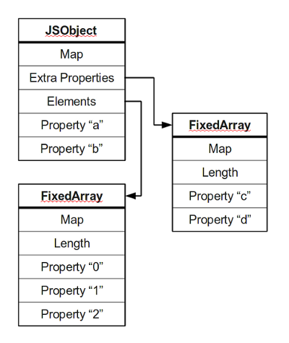

Most objects contain all their properties in a single block of memory (‘a’ and ‘b’). All blocks of memory have a pointer to a map, which describes their structure.

Named properties that don’t fit in an object are usually stored in an overflow array (‘c’ and ‘d’).

Numbered properties are stored separately, usually in a contiguous array.

The JavaScript standard allows developers to define objects in a very flexible way, and it is hard to come up with an efficient representation that works for everything. An object is essentially a collection of properties: basically key-value pairs. We can access properties using two different kinds of expressions:

* obj.prop
* obj[“prop”]

According to the spec, property names are always strings. If we use a name that is not a string, it is implicitly converted to a string. This may be a little surprising: if we use a number as a property name, it gets converted to a string as well. So a JavaScript object is basically a map from strings to values.